Overview of the analysis: Explain the purpose of this analysis.

The purpose of this analysis was to try and understand the relationship of our feature variables and how they played into the success of an applicant (in their respective ventures) when funded.

Data Preprocessing

* What variable(s) are the target(s) for your model?
  + The variable ‘IS_SUCCESSFUL’ is the target for this model
* What variable(s) are the features for your model?
  + Please refer to the image below
  + 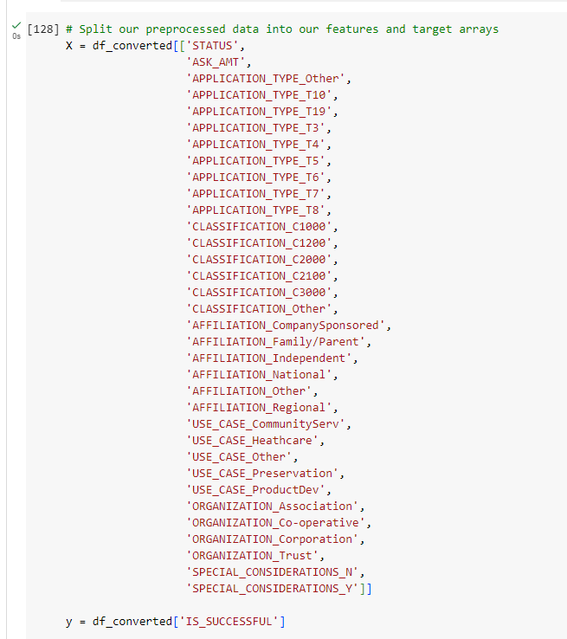
* What variable(s) should be removed from the input data because they are neither targets nor features?
  + Looking back, and considering the consistency in which the accuracy the algorithm came back, I would probably ‘STATUS’, ‘ORGANIZATION’, AND ‘SPECIAL CONSIDERATIONS’ as they could potentially hold no real value either as targets or features.

Compiling, Training, and Evaluating the Model

* How many neurons, layers, and activation functions did you select for your neural network model, and why?
  + To be honest, at first I was just trying to make my output the same or as close as possible to what the starter code had given. Once this was accomplished, and at the same time realizing how close those numbers got us to just even the 75% mark for the following section, I kept with similar sets of values while trying to meet and/or surpass that 75% threshold. (those numbers being 3, (80, 50, 1), and 2 unique activation functions). Looking back, I may have had better results had I started from the very beginning and reevaluated the features variables and then moved onto the neurons, layers, and activation functions…
* Were you able to achieve the target model performance?
  + Not quite, but fairly close!
* What steps did you take in your attempts to increase model performance?
  + I reconsidered the feature variables and which ones were converted from categorical to numeric values, types of activation functions, and the number of units used in each layer.

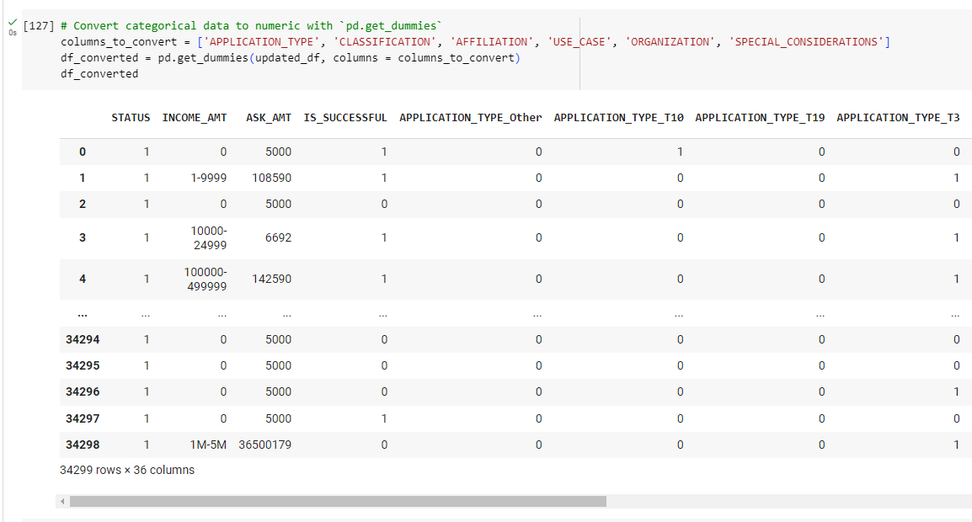

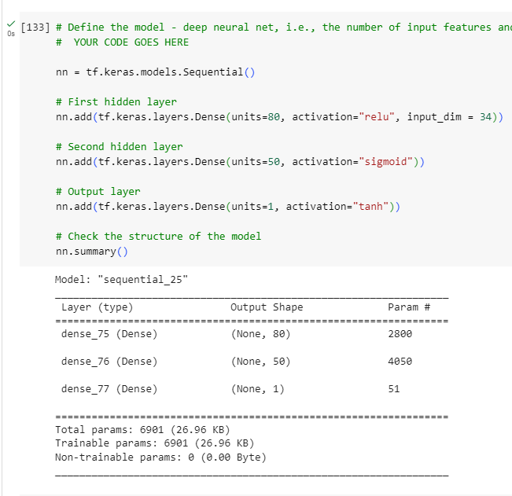

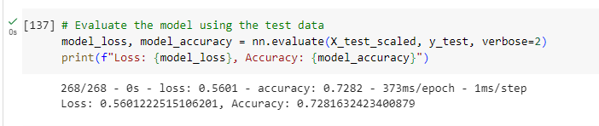

Summarize the overall results of the deep learning model. Include a recommendation for how a different model could solve this classification problem, and then explain your recommendation.

Overall, considering all that goes into funding a project and what rides on its success, I think we did fairly well. Being someone that scrutinizes every and all details, I am happy with the results. If this exercise was strictly about accuracy, then as stated above, there are aspects to this homework I’d reconsider manipulating thoroughly to achieve the highest mark possible (those being a different set of feature variables, and consequently, number of neurons, layers, and activation functions. Number of epochs may or may not change).